Bugs and features to improve

20170210-1

Reconstruction adds noise to the slices in each block. This is in particular visible in cases with large block size. This data was reconstructed using the single threaded back projector.

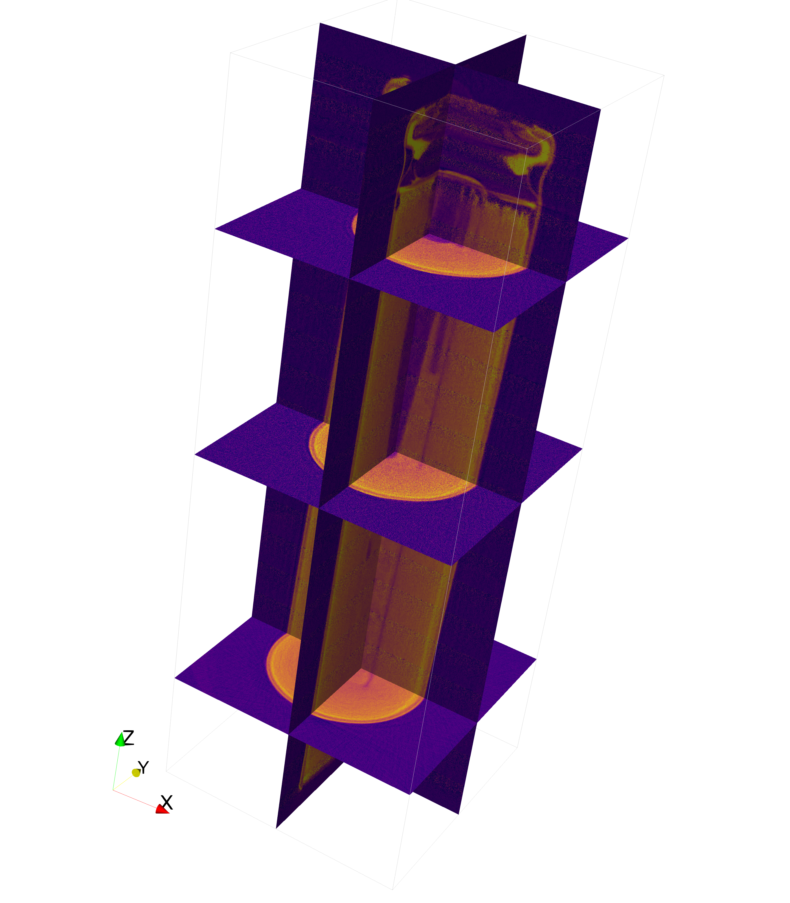

20170210-2

The recon history dialog doesn’t scale when dragged.

20170210-3

Recon history tilt estimate shall use center of projection instead of first slice in the stack as pivot.